This Apprenticeship Program Handbook serves as a TEMPLATE to customize for an employer’s registered apprenticeship program. Remove this page once you have reviewed and updated the handbook.

This template will provide the Apprentices with the essential information they will need to be successful.
- Update and personalize the marked placeholders including company name, logo, industry sector, and occupation and/or trade.
- Incorporate the suggested additional elements as well as colors, images and information.

Please note that this document is a resource for programs recognized by the Department of Labor/Office of Apprenticeship (DOL/OA). Additional elements may include:

1. Company Mission and Values: A short statement about the company’s mission and core values, emphasizing how the apprenticeship aligns with these principles.

2. Welcome Message from Leadership: A personalized message from a senior leader or program director, welcoming the Apprentice and expressing the importance of the program to the company.

3. Program Overview: A brief introduction to the Apprenticeship Program, outlining its purpose, goals, and benefits for both the Apprentice and the company.

4. Program Highlights: A bullet-point list of key features of the apprenticeship, such as mentorship opportunities, training, certifications, and potential career paths.

5. Important Dates: A calendar of key dates, such as start and end dates of the apprenticeship, important milestones, or scheduled training sessions.

6. Legal and Confidentiality Notice: A brief statement regarding the confidentiality of the handbook and any legal disclaimers, ensuring that apprentices understand the importance of keeping certain information private.

7. EEO/AAP Guidelines: Brief information on the rights of Apprentices in coordination with Apprenticeship rules CFR 29.30. Please visit WIN’s EEO/AAP Resource page for more customizable options to add to your handbook.

8. How to Use This Handbook: Simple instructions on how Apprentices should use the handbook, encouraging them to refer to it throughout their apprenticeship.

9. Acknowledgment of Receipt: A section where the Apprentice can sign and date to acknowledge that they have received and reviewed the handbook.

For additional assistance, please reach out to the Workforce Intelligence Network (WIN) team at info@winintelligence.org, call 313.744.2946 or visit miapprenticeship.org.

Remove this page once the handbook is reviewed and updated.



{INSERT COMPANY LOGO}

APPRENTICESHIP
PROGRAM GUIDE

COVER PAGE

TABLE OF CONTENTS
Welcome | Employer Mission, Values, Guiding Principles pg #
How Apprenticeship Works pg #
Apprenticeship Program & Overview pg #
Definitions
Support Services & Key Contacts
Applicant Qualifications
Apprenticeship Standards
Apprenticeship Registration Agreement
Probationary Period
Responsibilities
Related Training Instruction & Schedule
On the Job Training
Work Records
Credit Experience
Harassment & Discrimination
Complaint Procedure
Corrective Action
Layoffs/Suspensions
Military Active Duty
Apprenticeship Completion Requirements
Certificate of Completion
Equal Employment Opportunity/Affirmative Action Plan pg #
Reasonable Accommodation
Voluntary Disability Form
Safety
Training Capability Ratio
Wages, Hours & Benefits
Additional Information

You Are officially An Apprentice… ‘one-page check list’ pg #
Tips for A New Apprentice
Apprentice Preparation list

{INSERT COMPANY LOGO}

APPRENTICESHIP PROGRAM HANDBOOK
Congratulations on Taking Charge of Your Career!

Welcome to the {INSERT COMPANY NAME} Apprenticeship Program! This program helps you take charge of your career while working for a respected world leader in {INSERT SECTOR}.
Skilled {INSERT OCCUPATION} employees are in high demand. As our businesses continues to evolve and change, the need for experienced, talented workers such as {INSERT TRADE} increases. The opportunity to learn and grow with an organization like {INSERT COMPANY NAME} can help you carve out a promising future in the United States and Globally.
Our Apprenticeship Program offers a great career path, and our highly experienced mentors, coaches and leaders ensure that you’ll be learning from the best and working with skilled, dedicated teammates.

{INSERT DATE}
{INSERT APPRENTICESHIP LEAD CONTACT}
{INSERT COMPANY WEBSITE}
{INSERT COMPANY INFORMATION}

How Apprenticeship Works

The {INSERT COMPANY NAME} Apprenticeship Program combines supervision, structure, on-the-job training, related technical instruction and personal and professional development. As an {INSERT COMPANY NAME} Apprentice, you have certain rights under applicable Apprenticeship Regulations. With those rights come responsibilities and great opportunities to take ownership of your training and development.
At {INSERT COMPANY NAME} we wholeheartedly support all our employees and are committed to personal and professional development and training. Our Apprenticeship Program is based on and aligned with industry standards and developed based upon the Department of Labor Office of Apprenticeship (DOL/OA) rules and regulations.
The purpose of this handbook is to outline program expectations and policies to inform the Apprentice of their responsibilities. It is not intended to be a legal document and does not create a contract of employment. Please read it and use it for future reference.
Congratulations on taking this important step toward a successful, fulfilling career. We’re here to help you, every step of the way, and we’re proud to have you become part of the {INSERT COMPANY} family!



{INSERT COMPANY NAME}
Apprenticeship Program & Overview

{INSERT COMPANY NAME} partners with applicable Governmental Agencies in the development, implementation, administration and monitoring of its Apprenticeship Programs. The related technical instruction will be in classroom or online format and must align to the applicable Department of Labor/Office of Apprenticeship standards. Although the DOL/OA has responsibility for oversight of the Apprenticeship Program, both the Company and you, the Apprentice, have responsibilities as well.
Definitions
- Apprentice: a worker who is employed to learn an apprenticeable occupation training under a written agreement, including specific terms of apprenticeship and employment.
- Appendix A: official agreement between Department of Labor and program sponsor outlining the terms and conditions of the apprenticeship; includes the Work Process Schedule (OJT), Related Technical Instruction Outline, Apprentice Wage Schedule, Ratio of Apprentices to Journeyworkers, Type of Occupation, Term of Apprenticeship, Selection Procedures, and Probationary Period.
- Appendix B ETA-671 Apprenticeship Registration Agreement: official registration agreement from RAPIDS between Department of Labor, apprentice and program sponsor concerning the terms of on-the-job training, related technical instruction and wage schedule during a designated period.
- Department of Labor Office of Apprenticeship (DOL/OA): governing body for apprenticeship standards in Michigan.
- Joint Apprenticeship Committee (JAC): if unionized, a committee composed of employer and labor members sponsoring an apprenticeship program. Committees may represent labor and management interests at the national, state, or local level.
- Journeyworker: a worker who has attained a level of skill, abilities and competencies recognized within an industry as having mastered the skills and competencies required for the occupation.
- On-The-Job Training (OJT): structured hands-on experience during a set period of time learning the job’s skills set.
- Program Sponsor: (if applicable) may consist of individual employers, groups of employers, or combinations of employers and unions. A program sponsor is an organization with the capacity, expertise, and network to help businesses successfully create, launch, manage, and expand apprenticeship programs.
- Related Technical Instruction (RTI): Related Training Instruction is instruction providing knowledge of the theoretical and technical subjects related to trade. Essentially, the classroom learning component of a registered apprenticeship; may occur at a college, union, internally at a company, or valid private training provider.
- Registered Apprenticeship Partners Information Database System (RAPIDS): official apprentice registration database with the Department of Labor uses to register apprentice with DOL/OA approved registered apprenticeship and obtain ETA-671 Agreement.
- Suspension: the official term used by the DOL/OA when an apprentice has to suspend their apprenticeship for a specific period time due to layoffs, recovery from illness or injury, parental leave or other life changes. Also known as pausing apprenticeship.
Support Services | Key Contacts
{INSERT COMPANY NAME} is committed to your success professionally and personally. If you should at any time have questions, concerns, or have a life event that may impede your success, please contact {insert key contact, phone, email/text} so that support services and appropriate action may be taken.
Applicant Qualifications
- Age: [Enter Minimum Age Requirement]
- Education: [Enter Education Requirement]
- Physical: [Enter Physical Requirements]
Apprenticeship Sponsor
Program sponsors also known as “apprenticeship intermediary” may be governmental agencies at all levels, including universities and the military. An apprenticeship intermediary is an organization with the capacity, expertise, and network to help businesses successfully create, launch, manage, and expand apprenticeship programs. This organization is called the program sponsor or standards-holder of their apprenticeship program. Your program sponsor is {INSERT ORGANIZATION NAME}


Apprenticeship Registration Agreement & Appendix A
Apprenticeship Appendix A is a legal, binding document between you, {INSERT COMPANY NAME}, and the DOL/OA that outlines the terms and conditions of the apprenticeship including related training instruction (RTI), on the job training (OJT), and wage schedule. Your Apprenticeship Registration Agreement (Appendix B/ETA-671) is {INSERT LENGTH OF PROGRAM} with {INSERT NUMBER OF RTI HOURS}.
Failure to complete the required OJT and RTI hours in the time frame specified may result in termination from the program. If you do not have a copy already, request a copy of {Insert occupation} Appendix A from the {apprenticeship contact name} Please take time to review your copy of the Agreement. It should be thoroughly understood.
RAPIDS
Official apprentice registration database the Department of Labor uses to register apprentice with DOL/OA approved registered apprenticeship and obtain ETA-671 Agreement. Once approved by the DOL/OA after registration, it will require you, the Apprentice and {Insert company name} signature.
Probationary Period
A Probationary Period is required in each apprenticeship. It provides an opportunity for both the Company and the Apprentice to get acquainted and learn about the program. Should either you or the Company wish to cancel the Agreement during the Probationary Period, either party can do so by notifying the other of the decision in writing.
Responsibilities
As an Apprentice, you are expected to:
- Work safely in accordance with applicable {INSERT COMPANY NAME} policies and division-specific work rules.
- Comply with company absenteeism and tardiness policies at work and school.
- Attend and participate in related instructional and educational programs, maintaining the highest possible grades.
- Show dedication to your training both on the job and in the classroom, performing the work of the trade diligently and faithfully.
- Maintain records and keep track of your training hours {ENTER TRACKING SOFTWARE such as WORKHANDS} as required and notify your supervisor of any deficiencies and questions.
- Respect the skilled journeyworker(s) training and supervising you.
- Comply with the provisions of the Apprenticeship Registration Agreement.
- Follow {INSERT COMPANY NAME} written work rules and applicable policies and procedures.
- Conform with safe working procedures as instructed to assure personal safety as well as the safety of fellow workers.
The Company is responsible for:
- Providing a safe working and learning environment.
- Ensuring supervision and training by a journeyworker on the job site.
- Offering well-rounded training so that the Apprentice learns all aspects of the trade by the completion of the training program.
- Monitoring the Apprentice’s on-the-job progress and providing feedback on performance.
- Complying with the provisions of the Appendix A and Appendix B (ETA-671) Apprenticeship Registration Agreement.
- Managing training expenses at the business site level and reviewing them regularly.
- Intending to provide continuous full-time employment and training to Apprentices, though permanent employment cannot be guaranteed.
- Maintaining proper apprenticeship records including up to date OJT and RTI tracking.



Related Technical Instruction | School Training
Your Related Technical Training Provider is:
{Insert RTI Provider Name}
{Insert RTI Contact Information}
{Insert total RTI Contact Hours}
Apprenticeship training combines several aspects as part of an overall strategy to train a skilled worker, including supervised, structured OJT and related instruction. The importance of related instruction is twofold: the industry has uniformity of instruction and you, as an individual Apprentice, are given the theoretical knowledge of your trade. This is what adds value to you as an individual, to your career, and to your industry. Related instruction is an integral part of every apprenticeship and is required by the DOL/OA apprenticeship regulations. The related instruction is the academic portion of the apprenticeship, and is usually provided by the applicable technical school, proprietary school and/or online.
On-The-Job Training |Work Process Schedule
The on-the-job training schedule outlines the major job functions, competencies, and/or hours an apprentice completes in a registered apprenticeship program. It outlines what apprentices are expected to learn on the job with the support of a mentor. The {INSERT OCCUPATION} program is {Insert Years or Hours depending on if time based, or competency based}.
Work Records
You are required to partner with the Company and maintain a record of your progress. The Company will also maintain a record of hours worked by you as part of your apprenticeship. Because the training and schooling extends over several years, a record is required to ensure all parts of the program have been covered and completed. Also, if discrepancies concerning training hours occur, both record books will be referenced to determine the hours worked. Your official work records must be approved and dated on a regular basis by you and your supervisor.
Credited Experience
An Apprentice can obtain an apprenticeship credit for their RTI and OJT. To obtain a credit, the Apprentice must have in writing from a previous authorized employer or demonstrate achievement/proficiency to current employer to satisfy a portion of the apprenticeship requirements as identified in the Appendix A.
An Apprentice can obtain advanced standing or credit for demonstrated competency, acquired experience, training, or skills for all applicants equally, with commensurate wages for any progression step so granted.

Harassment and Discrimination
Apprentices have the right to a harassment-free workplace and school setting. Please refer to Employee Company Policy for details.
Complaint Procedure
A complaint is a question or request for assistance to solve a problem or alleged problem regarding any part of the Apprenticeship Program. If you have a concern or complaint related to your apprenticeship training, please discuss it with your supervisor.
If you would like to pursue the complaint further, the complaint must be made in writing and submitted to the {DESIGNATED HUMAN RESOURCES REPRESENTATIVE}. The Company will work with you and any relevant parties to address the situation and seek a resolution.
Corrective Action
You may be subject to corrective action procedures when failing to make satisfactory progress or failing to meet your responsibilities in the Apprenticeship Program. In addition, behaviors that could lead to disciplinary action or the termination of your apprenticeship include, but are not limited to:
• Failure to abide by safety procedures and Company policies;
• Failure to follow work rules and procedures established by the Company;
• Disruptive behavior on the job or in related instruction;
• Failure to follow the directions of your supervisor and/or journeyworker;
• Failure to submit OJT records as required;
• Failure to fulfill all related instruction requirements;
- Failure to submit related instruction transcripts;
• Unsatisfactory grades for related instruction courses;
• Unsatisfactory attendance (including tardiness) for related instruction courses;
• Unsatisfactory attendance (including tardiness) at the job site; and
• Failure to register for related instruction.
Layoffs | Suspension
If a reduction in workforce becomes necessary, the suspension and reinstatement of Apprentices will be conducted in accordance with site specific rules. If you are laid off because of lack of work, the Company has the option of listing you as suspended/paused rather than terminated. The following conditions may apply:
- The Apprentice may be listed as inactive for a maximum of 12 months.
- If the layoff lasts longer than 12 months, the Apprentice will be terminated but is still entitled to be reinstated or recalled for two years from the original date of layoff.
- An inactive Apprentice may still be registered and attending approved classroom and/or online training; however, they will not accumulate OJT hours toward the completion of the program.

- All suspensions must be submitted to RAPIDS.

Military Active Duty
If called to active duty, the Apprentice Agreement may be placed on hold. Reinstatement will be governed by the DOL/OA and the Company.
Apprenticeship Completion Requirement
The Apprenticeship Registration Agreement (ETA-671) specifies the length of time that is required to graduate as a journeyworker within your trade. The completion of registered apprenticeship program is based on satisfactory performance and accomplishment of these required objectives:
- Completion of ‘Work Process Schedule’ which may be stated in total years or hours or a combination of both years and hours, depending on your specific trade. Documentation from {insert company} indicating the progress and completion is required.
- Completion of ‘Related Training Instruction’ the required hours of related classroom and/or online instruction as listed in Appendix A for your trade from the designated training provider.
Certificate of Completion
Once the Apprentice has satisfactorily completed their apprenticeship, the Apprentice will be issued a National Certification of Completion by the Department of Labor Office of Apprenticeship stating program requirements have been met. The completion must be submitted in RAPIDS and approved by the DOL/OA to obtain.
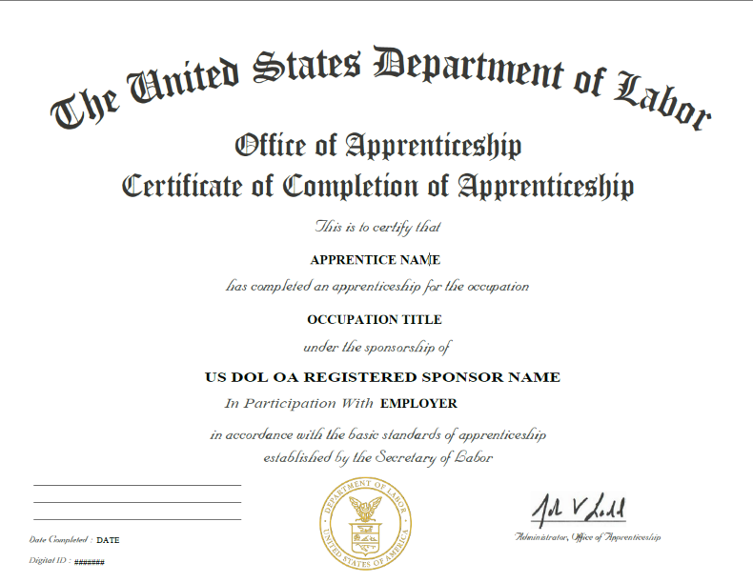

Equal Employment Opportunity/Affirmative Action Plan
{INSERT COMPANY NAME} is an equal opportunity employer. Employment decisions are made without regard to sex, race, age, disability, religion, national origin, color, or any other protected class.
Reasonable Accommodation
As an Apprentice, is your right to review reasonable accommodation if applicable. Reasonable accommodation is any change or adjustment to a job or work environment that permits a qualified Apprentice with a disability to participate in the job application process, to perform the essential functions of the job, or to enjoy benefits and privileges of employment equal to those enjoyed by employees without disabilities.
Voluntary Disability Form
The Voluntary Self-Identification of Disability Form is a way for Apprentices to disclose any disabilities they have to the Company. This is largely done to ensure that you have all the necessary accommodations required to do your job properly.
Safety
The Company will instruct the Apprentice in safe and healthful work practices and procedures and will ensure that the Apprentice is trained to safely carry out their job duties in compliance with applicable federal, regional and local occupational safety and health regulations and standards. The Apprentice will be held accountable for following all health & safety rules, work practices and procedures always.
Training Capability Ratio
The worksite ratio will comply with applicable ratio requirements of 1 Apprentice per 1 Journey worker {change ratio if different for your occupation} unless otherwise stated by the Department of Labor Office of Apprenticeship State Director.
Wage, Hours, and Benefits
The workday and work week for Apprentices will be determined by the Company. It is encouraged that Apprentices are employed during daytime shifts to allow direct supervision by a journey worker or supervisor of Apprentices.
Apprentices will start at a percentage of journey person pay and wage increases will be based both on time and performance. Apprentices will receive wages in accordance with the currently effective wage schedule listed in Appendix A and Appendix B Apprenticeship Registration Agreement (ETA-671).
The Company must comply with all applicable federal, state, and local laws relating to the payment of wages and work hours.
Additional Information
To learn more about your rights as an Apprentice please visit PART 30—EQUAL EMPLOYMENT OPPORTUNITY IN APPRENTICESHIP at: https://www.ecfr.gov/current/title-29/subtitle-A/part-30

This Workforce Intelligence Network (WIN) Data and Research workforce product was developed with support from our ten-community college and seven Michigan Works Agency partners. The product was created by (WIN) and does not necessarily reflect the official position of our partners. Neither WIN nor WIN Partners make any guarantees, warranties, or assurance of any kind, express or implied, with respect to such information including any information on linked sites and including, but not limited to, accuracy of the information or its completeness, timeliness, usefulness, adequacy, continued availability or ownership. This product is copyrighted by the institution that created it.
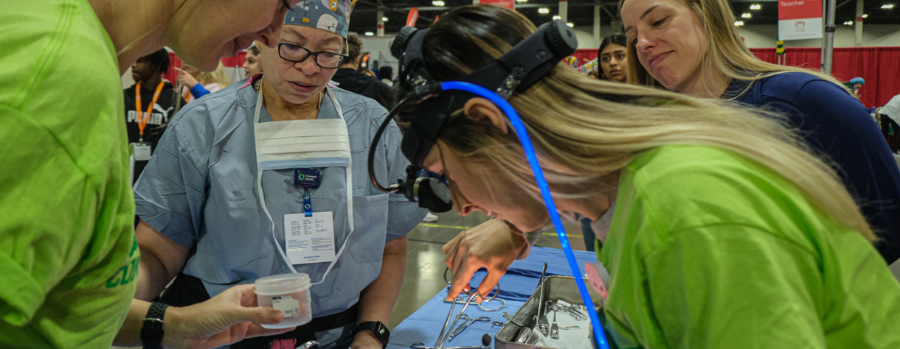
The Apprenticeship Building America program is supported by the U.S. Department of Labor. A total of $5,6 million, or 90% of the program is financed with federal funds and $100,000, or 10% is funded by other sources.
SO NOW YOU ARE AN APPRENTICE?.... What do I need to know?

Tips for a New Apprentice!
- SAFETY is always #1. Always maintain safe working procedures.
- Be organized! Keep a folder with all relevant apprenticeship information and documentation.
- Don’t be afraid to ask questions.
- Ensure you have a copy of the Appendix A which includes, work process schedule, related technical instruction outline and wage schedule.
- Be reliable and punctual (recommendation: arrive 15 minutes early).
- Keep records of completed RTI and OJT (and have a back-up).
- Have key contact information handy including journeyworker, apprenticeship contact lead and human resources representative.
- Be a present and enthusiastic learner!
- Have effective time management skills, be productive and committed to the work and team.
- Be professional! Follow company expectations and requirements.

Apprentice Preparation List
☐ Copy of Appendix A (OJT outline, RTI, Wage Schedule)
☐ Copy of Apprenticeship Registration Agreement (ETA-671)
☐ Apprenticeship Lead Contact Information
☐ Supervisor “Journey worker” Contact Information

